Execute the script shown in the video.

Verions :

Changing in terraform providers version may get us into incompatability issues.
By default terraform will always try to downlaod the latest version of provider available from registry.

Created a sample main.tf file , and performed “terraform init”
By default terraform dowloads latest version 2.6.2.

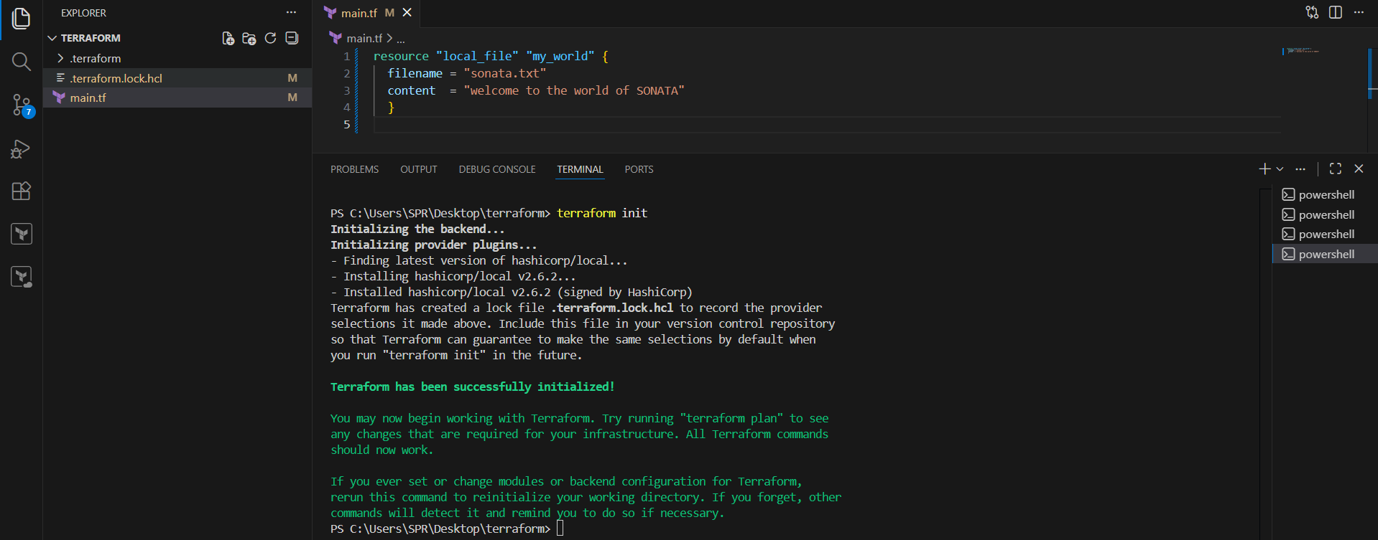

To make sure to use the specific version provider we can add the provider block in configuration.

TERRAFORM PROVIDER BLOCK : We can find terraform block in terraform registry , select the provide --> version required --> select use provider .

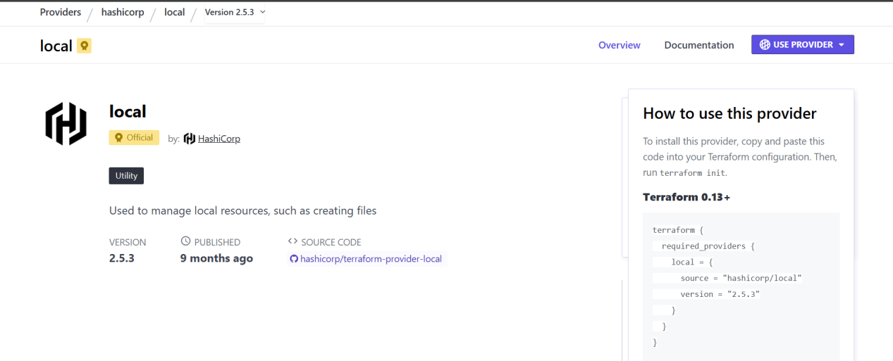

Example:
=======
terraform {
required_providers {
local = {
source = "hashicorp/local"
version = "2.3.0"
}
}
}

resource "local_file" "my-pet" {
filename = "pets.txt"
content = "I love cats!"
}

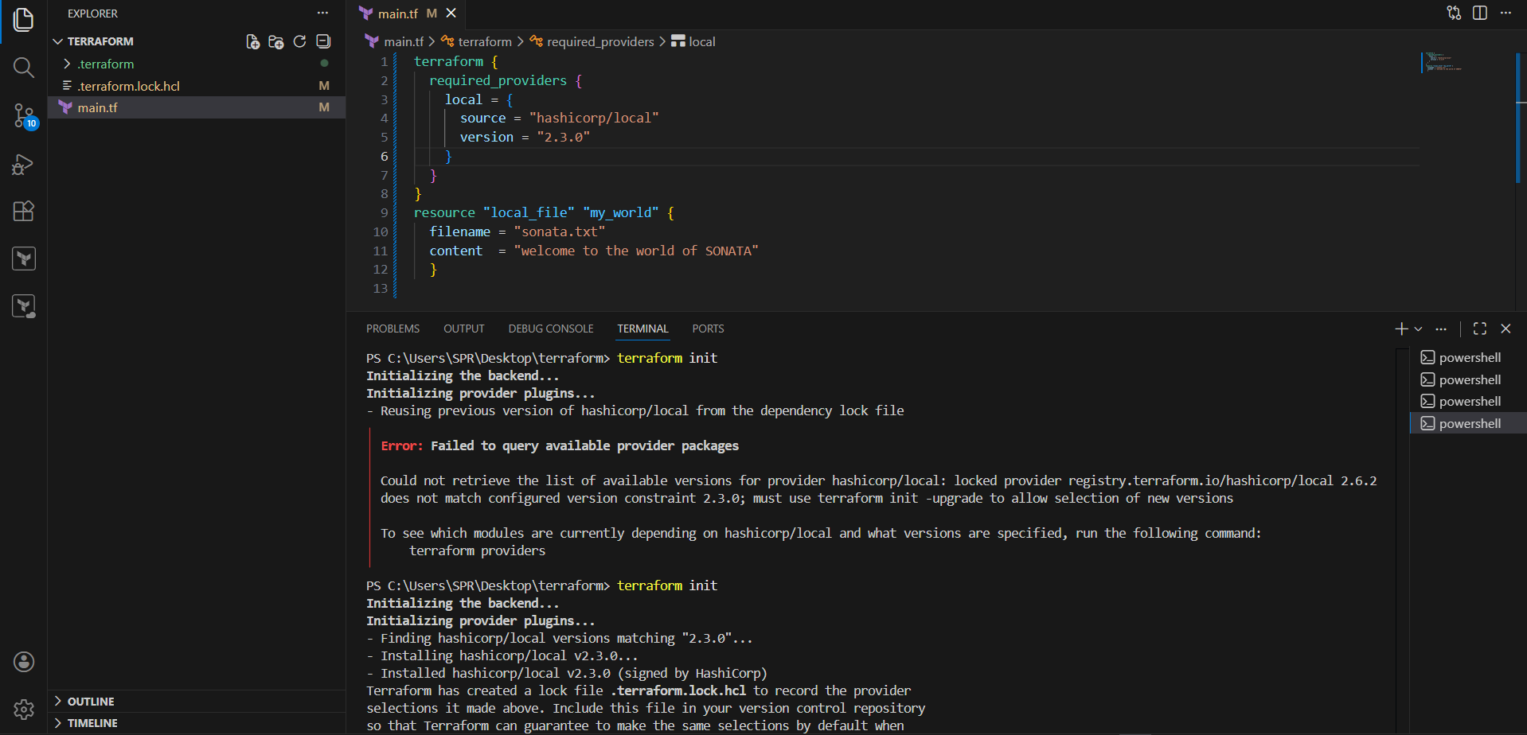

We will get error of available provider plugins , make sure delete “.terraform ” folder and backup file created “terraform.lock.hcl” .

=========
version = "2.3.0" --> download the exact version
version = "!=2.3.0" --> will not use the mentioned version . it installs other version except 2.3.0.

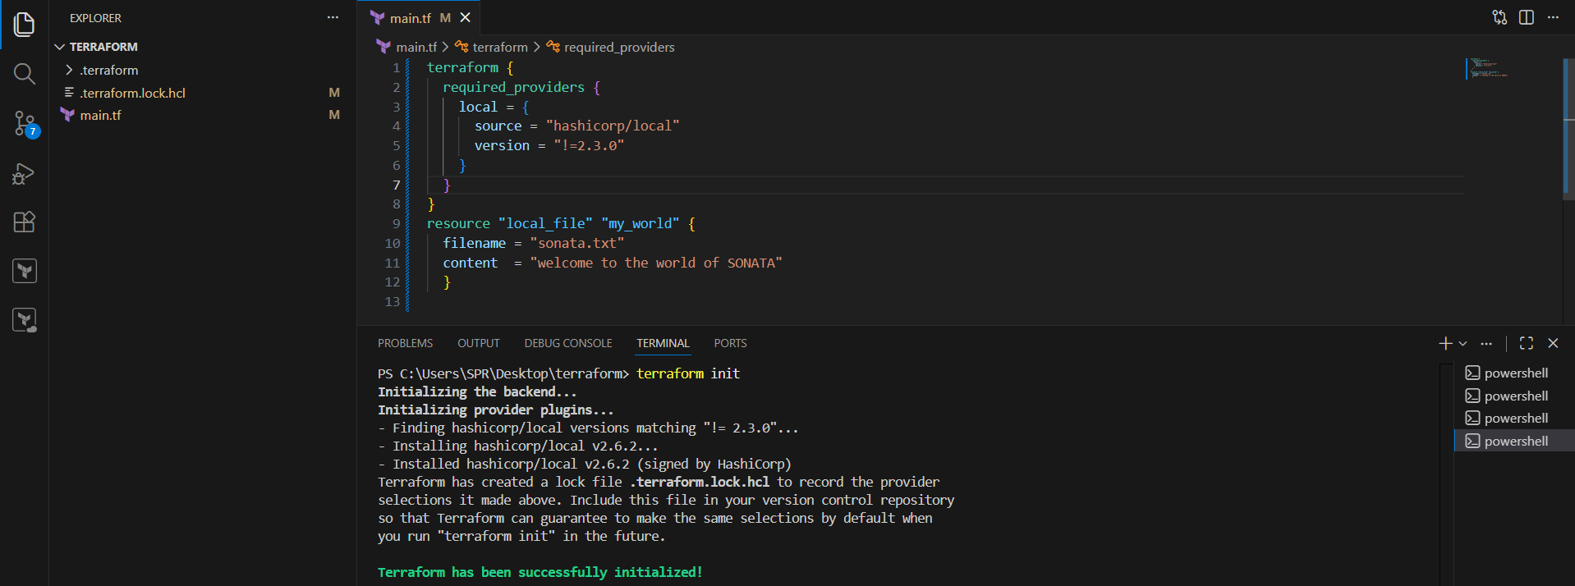

version = "< 2.3.0" --> lesses than the mention version

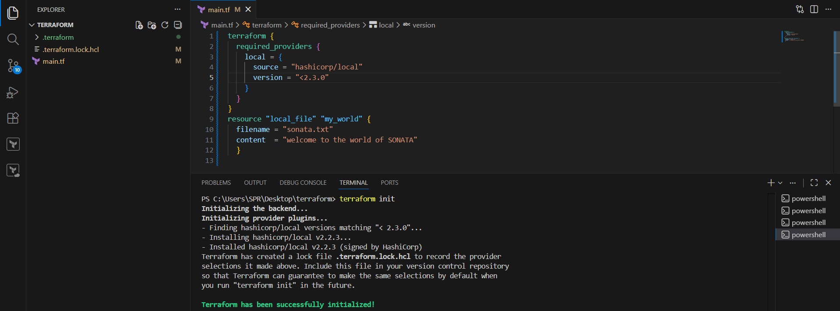

version = "> 2.3.0" --> greater than the given version

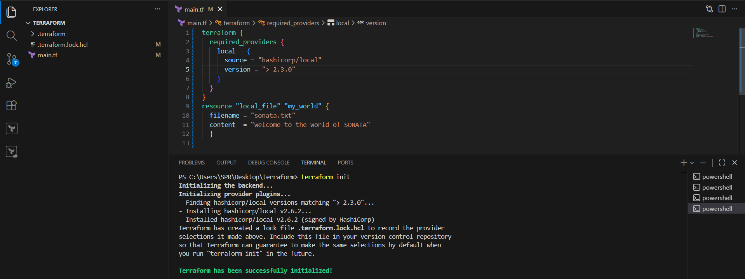

version = "~> 2.3.0" --> specific version or higher version.

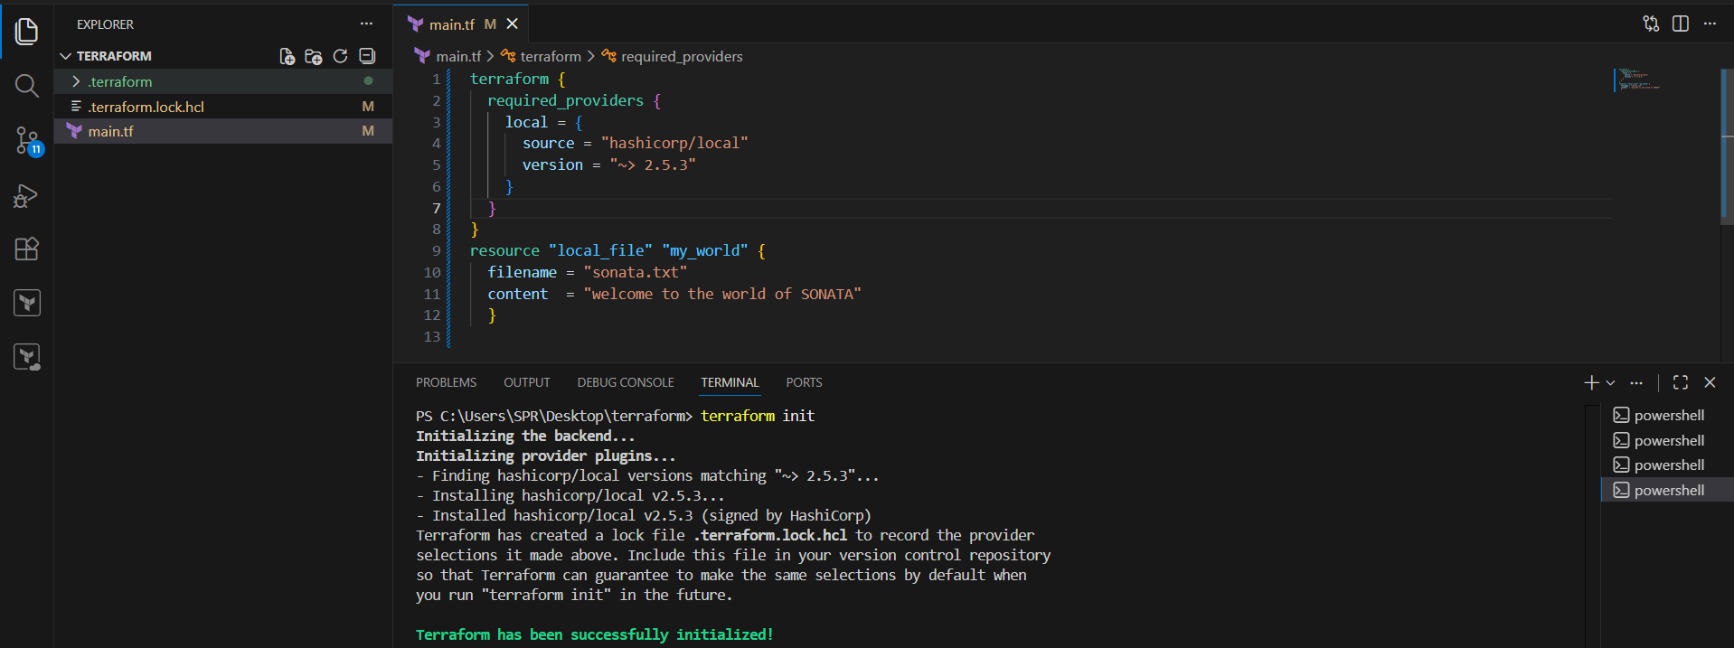

Resource block :
a resource block is used to create and manage infrastructure components like EC2 instances, S3 buckets, VPCs, databases, etc.
resource "aws_instance" "myserver" {
ami = "ami-0abcd1234"
instance_type = "t2.micro"
}

resource "local_file" "my_world" {
filename = "sonata.txt"
content = "welcome to the world of SONATA"
}

Resources starts with keyword resource
resource are used to create,modify,delete the infra.

Data blocks : Data sources are used to read and fetch the content of the infrastructure.

Syntax : data "<provider>_<resource_type>" "<name>" {
argument = value
}

Example : if we want terraform to read the content of the file which has been created by any other tool.

create a text document called in dogs.txt in the same terrafrom working directory.

main.tf
======

resource "local_file" "my-pet" {
filename = "pets.txt"
content = data.local_file.dog.content
}
data "local_file" "dog" {
filename = "dogs.txt"
}

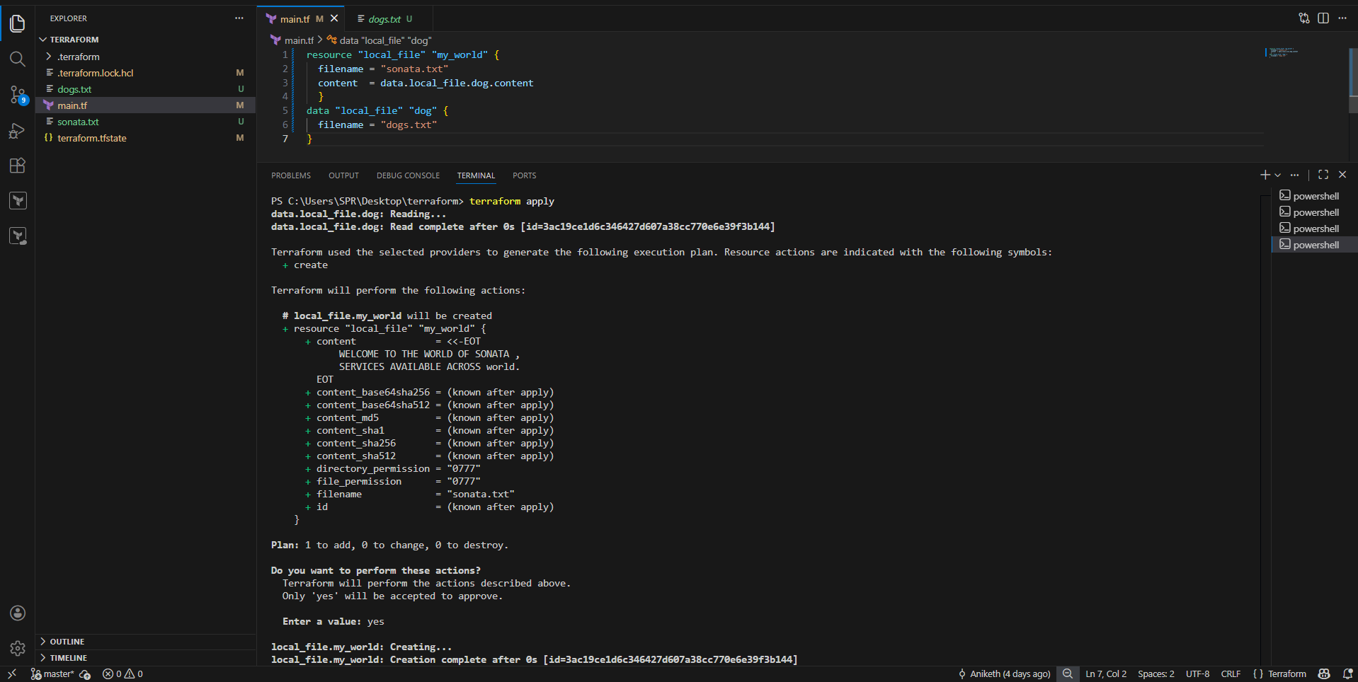

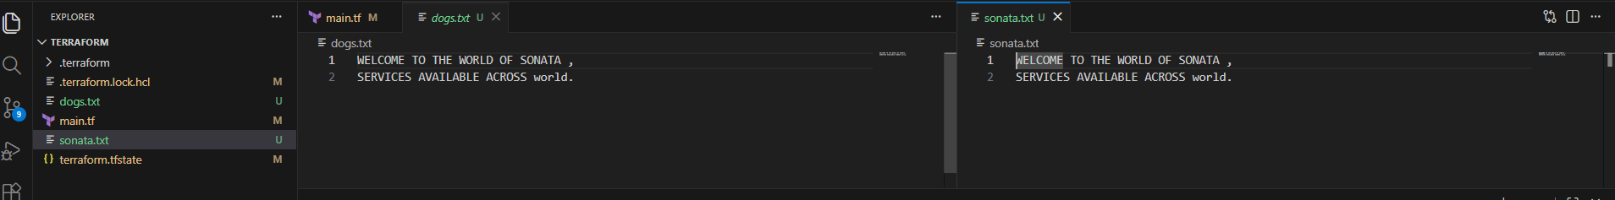

Difference between resources and data ?

Resources starts with keyword resource
resource are used to create,modify,delete the infra

Data source strat with keyword data.
data sources are used to read the infrastructure.

Meta Arguments :

Meta arguments are used if we want to create multiple resources.
Meta arguments can be used within any resource block to change the behaviour of the resources.
Examples for meta arguments:

1) Depends_on
2) lifecycle rules
3) Count
4) For_each

Example of count:
================
If we use count as 3 then it will create 3 files with world[0],world[1],world[2]

resource "local_file" "my-world" {
filename = "pets.txt"
content = "I love cats!"
count = 3
}

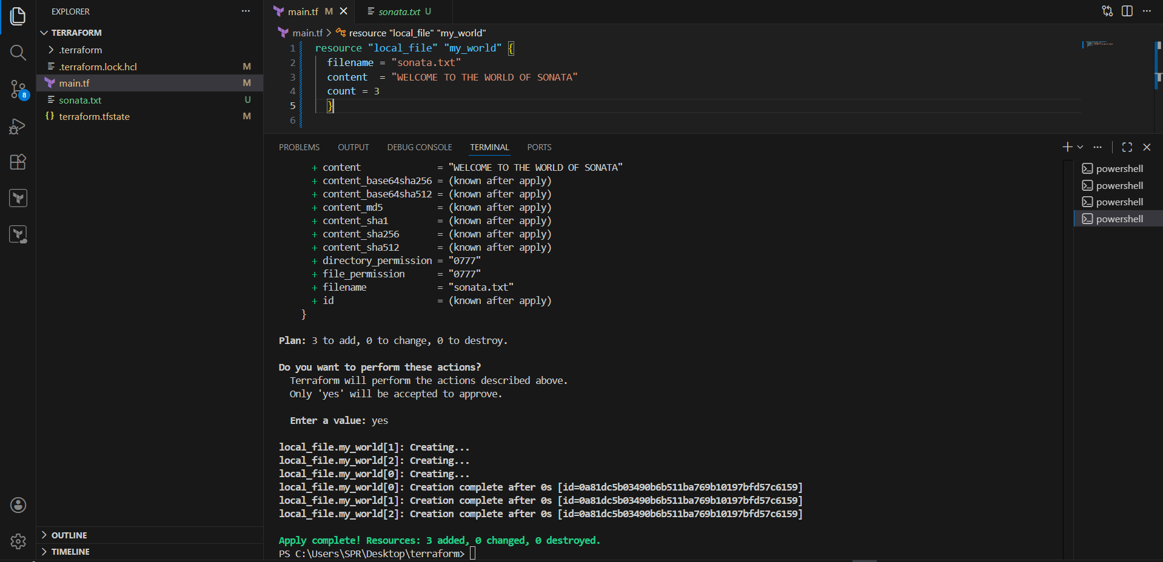

This is not the ideal way to use because these are getting replaced.

Modify the main.tf file :

resource "local_file" "my-pet" {
filename = var.filename[count.index] -->
content = "I love cats!"
count = 3
}

Add variables.tf file :

variable "filename" {
default = [
"pets.txt"
"cats.txt"
"dogs.txt"
]
}

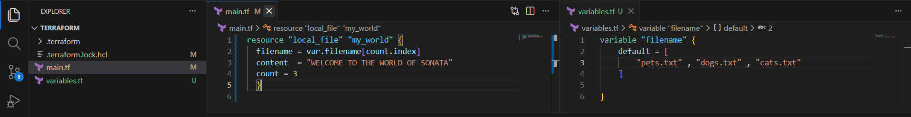

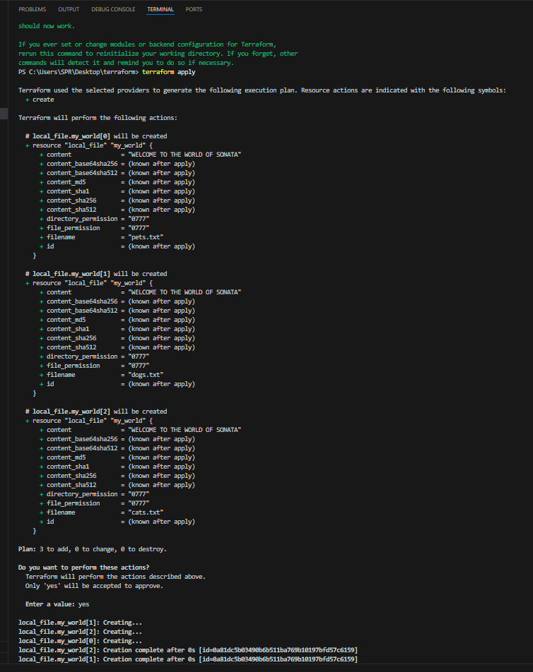

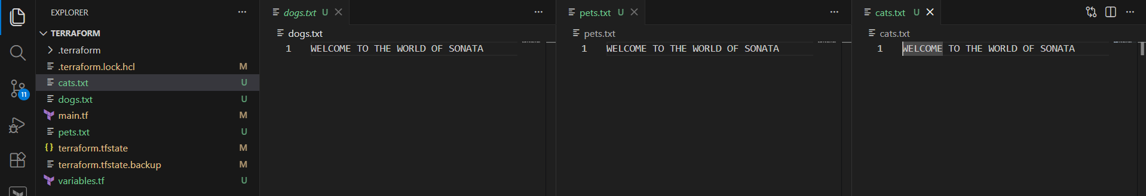

Still we have problem in the above configuration,if in future the list of varibles then we need to change the count value manually.
to avoid this we can use the inbuilt lenth function in terraform.

Modify main.tf file :

resource "local_file" "my-pet" {
filename = var.filename[count.index]
content = "I love cats!"
count = lenght(var.filename)
}

variables.tf

variable "filename" {
default = [
"pets.txt"
"cats.txt"
"dogs.txt"
]
}

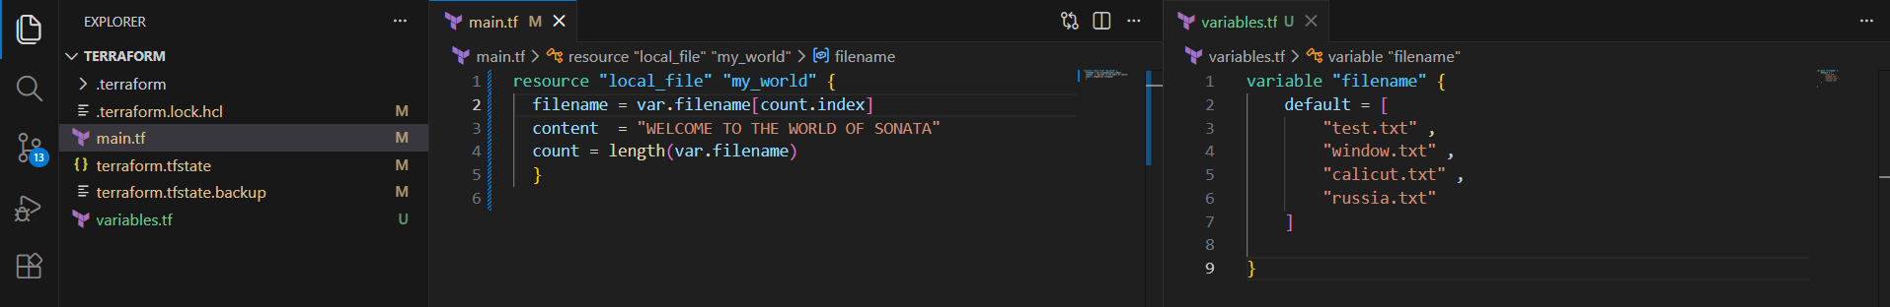

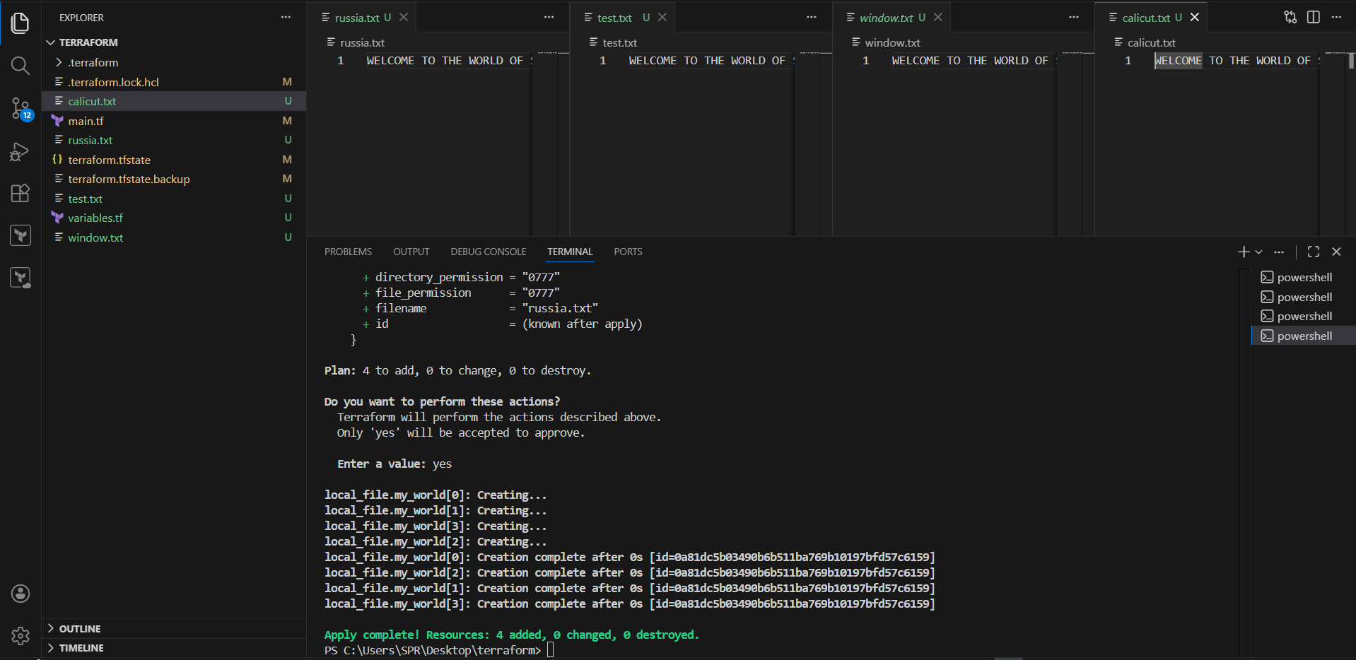

But when we want to update/destroy any one file then we will see un wanted results in count as count will store the output in list and works on index number.

to overcome the issue we have for_each meta argument.

Example of for_each:
====================
main.tf:

resource "local_file" "pet" {
filename = each.value ----> each.value = the value of the current item in the loop.
Content = "WELCOME TO THE WORLD"
for_each = var.filename
}

variables.tf
============

variable "filename" {
type=set(string) --> add this to overcome error for “for_each” argument.
default = [
"pets.txt"
"cats.txt"
"dogs.txt"
]
}

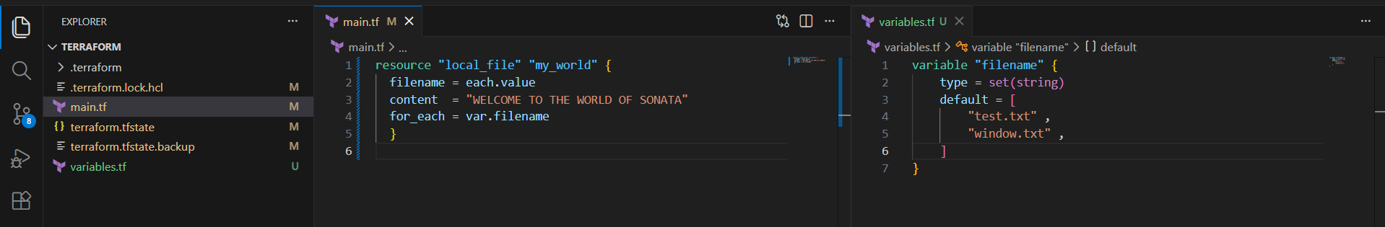

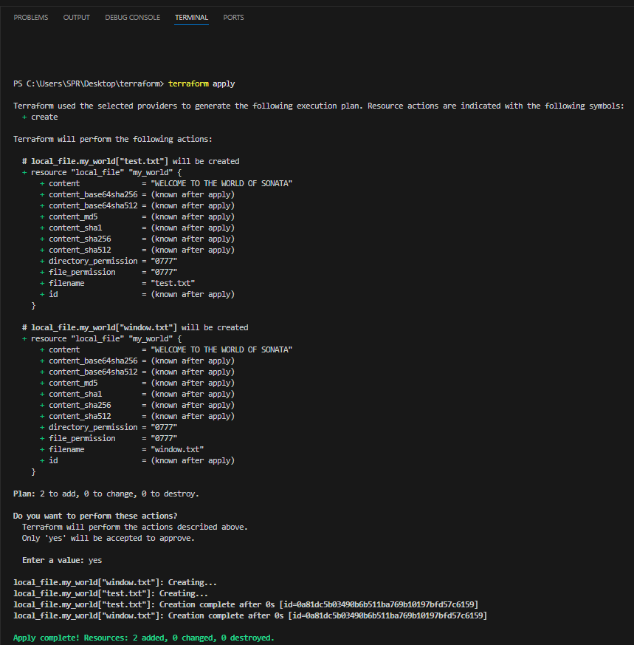

or if you want to use list varibale then we can change the main.tf with toset inbuilt function.

main.tf:

resource "local_file" "pet" {
filename = each.value
content = "welcome to world"
for_each = toset(var.filename)
}

variables.tf
============

variable "filename" {
default = [
"pets.txt"
"cats.txt"
"dogs.txt"
]
}

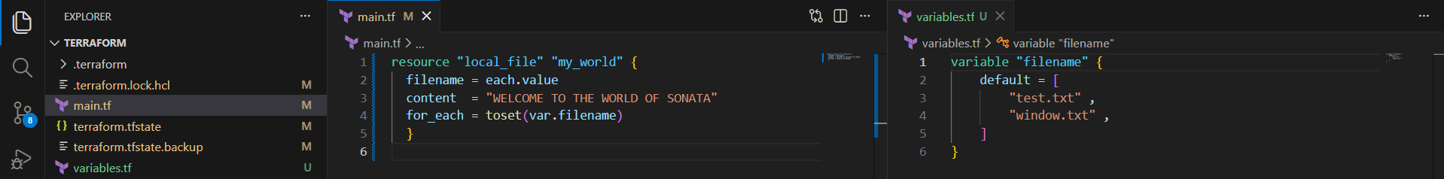

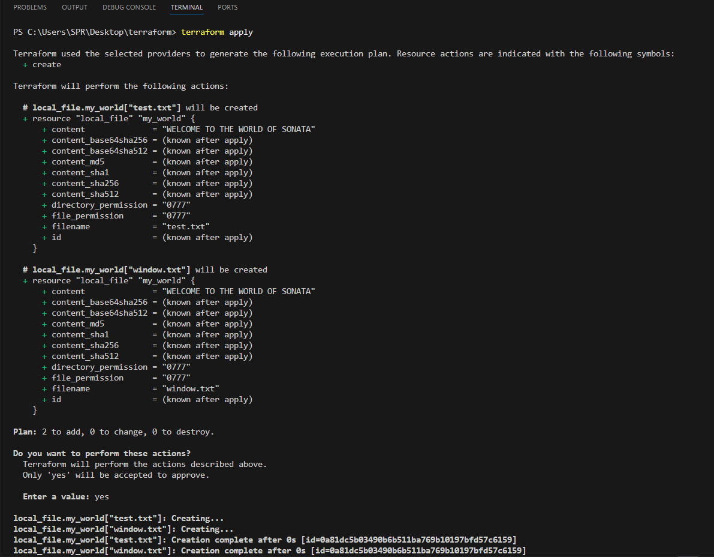

Count will store the output as list and identified based on indexnumber
foreach store the output as map and identified based on filename.

Creation of aws sevices with terraform :

--> first we need to create a secret key and access key and configure then in laptop.
--> go to terraform registry, check for the provider and check the resources availale , required parameters , attributes can be used .

Example script to create aws iam:
================================

resource "aws_iam_user" "Admin-user" {
name = "lucy"
tags = {
"description" = "Technical Team Lead"
}
}

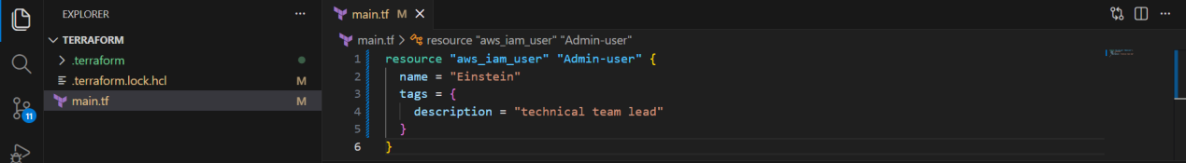
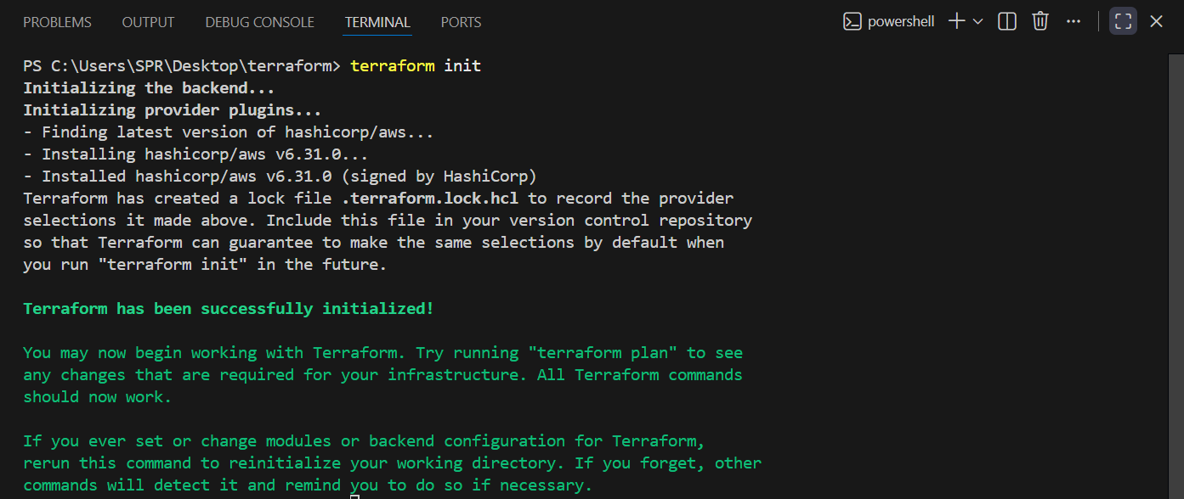

Configure aws in local ,.

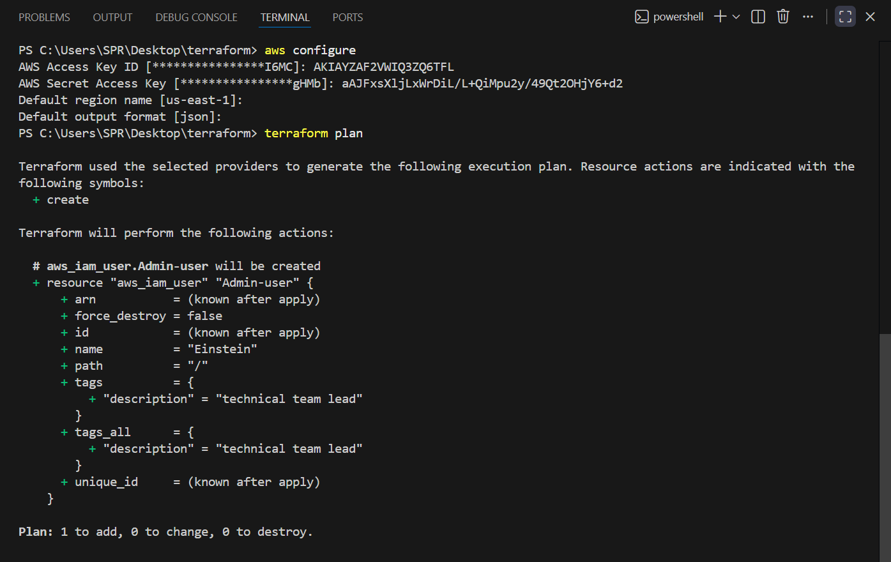

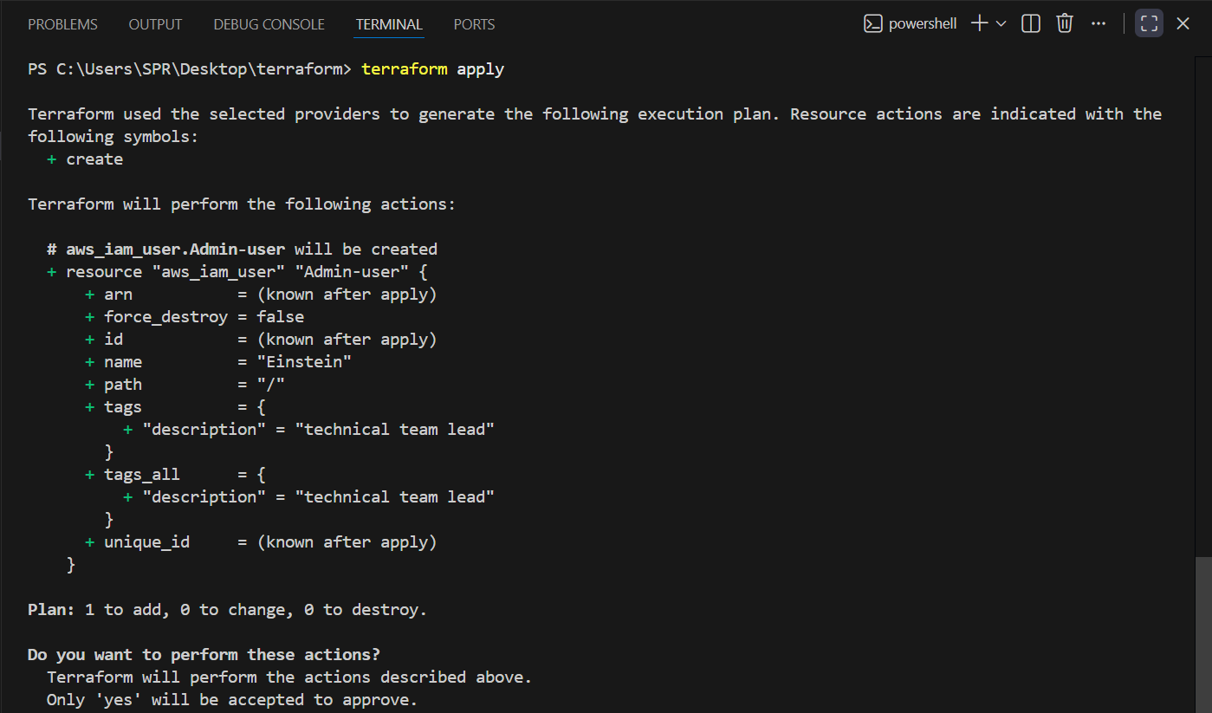
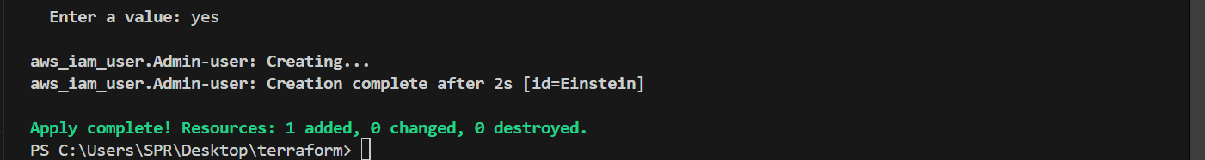

Check in AWS , user will get created .

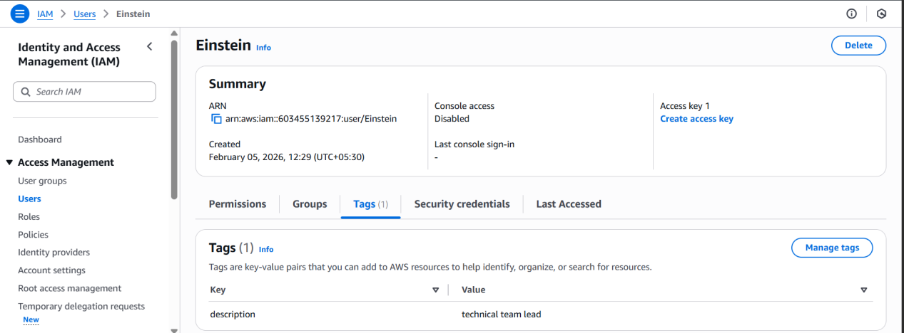

Example script to create iam user with policy attached to the user:
===================================================================

resource "aws_iam_user" "Admin-user" {
name = "lucy"
tags = {
"description" = "Technical Team Lead"
}
}
resource "aws_iam_policy" "adminuser" {
name = "AdminUsers"
policy = <<EOF
{
"Version": "2012-10-17",
"Statement": [
{
"Sid": "1234567890",
"Effect": "Allow",
"Action": "*",
"Resource": "*"
}
]
}
EOF
}

resource "aws_iam_user_policy_attachment" "lucy-admin-access" {
user = aws_iam_user.Admin-user.name
policy_arn = aws_iam_policy.adminuser.arn
}

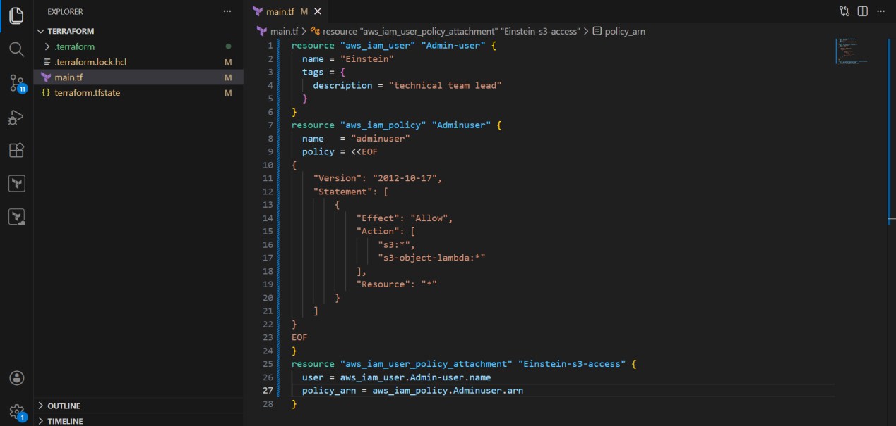

In the above example we have added the json policy using "heredoc syntax" and delimeters "EOF --> End of file" inside the main.tf.

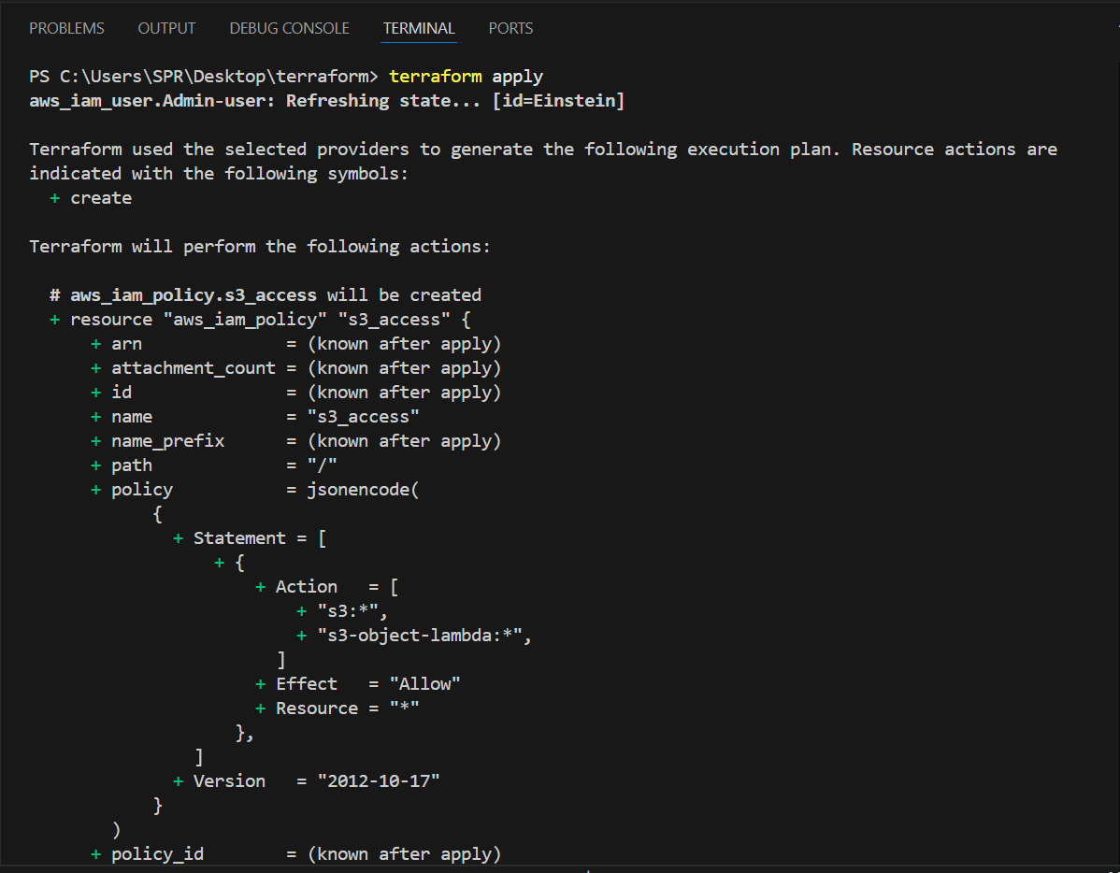
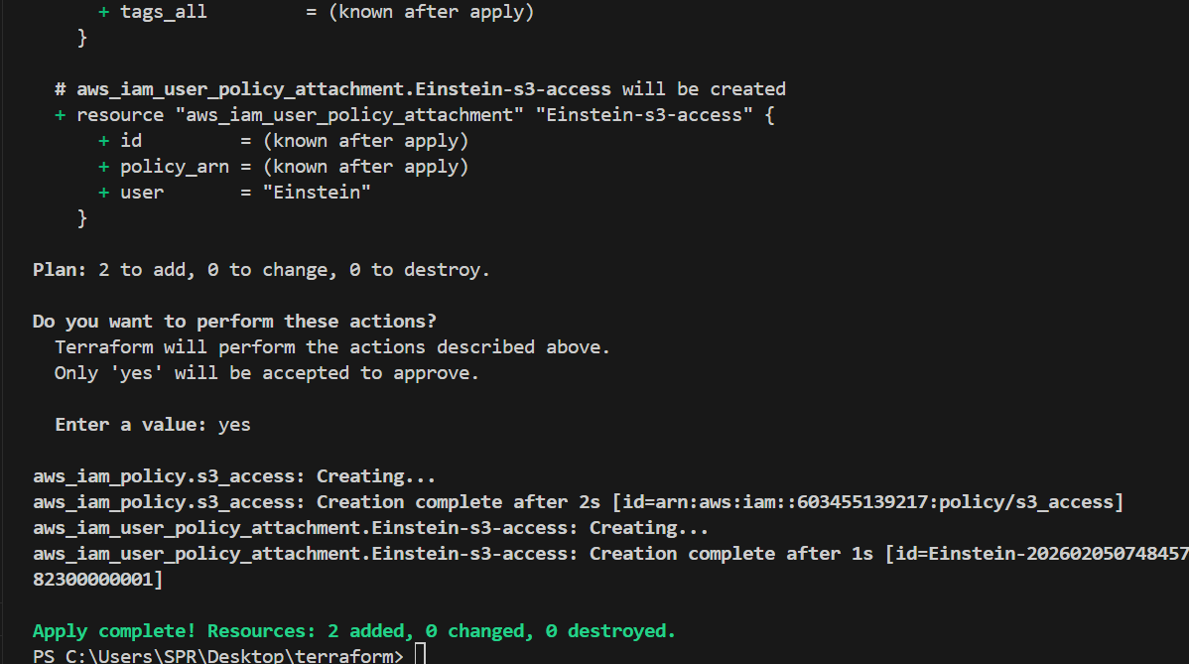

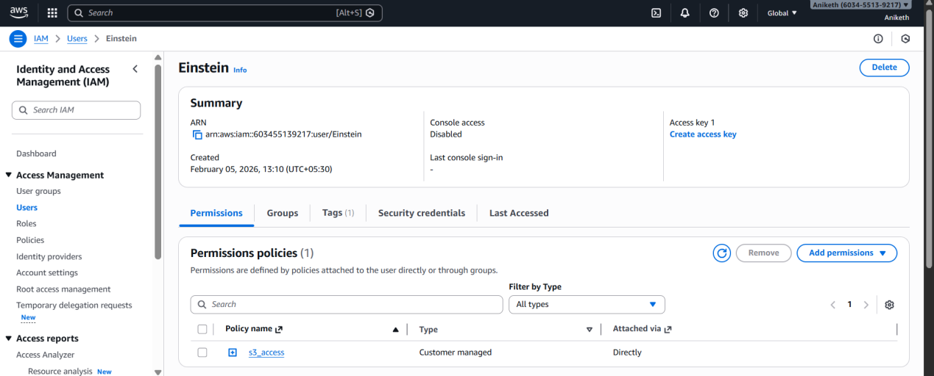

we can also use them by saving the template in seperate file and call that file in our main.tf.

Example:
=======
admin-policy.json
=================
{
"Version": "2012-10-17",
"Statement": [
{
"Sid": "1234567890",
"Effect": "Allow",
"Action": "*",
"Resource": "*"
}
]
}

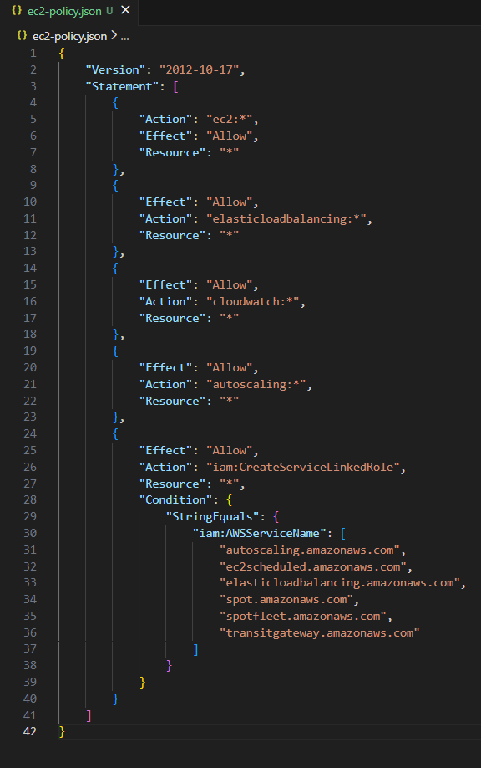

main.tf:
======

resource "aws_iam_user" "Admin-user" {
name = "lucy"
tags = {
"description" = "Technical Team Lead"
}
}
resource "aws_iam_policy" "adminuser" {
name = "AdminUsers"
policy = file("admin-policy.json")
}

resource "aws_iam_user_policy_attachment" "lucy-admin-access" {
user = aws_iam_user.Admin-user.name
policy_arn = aws_iam_policy.adminuser.arn
}
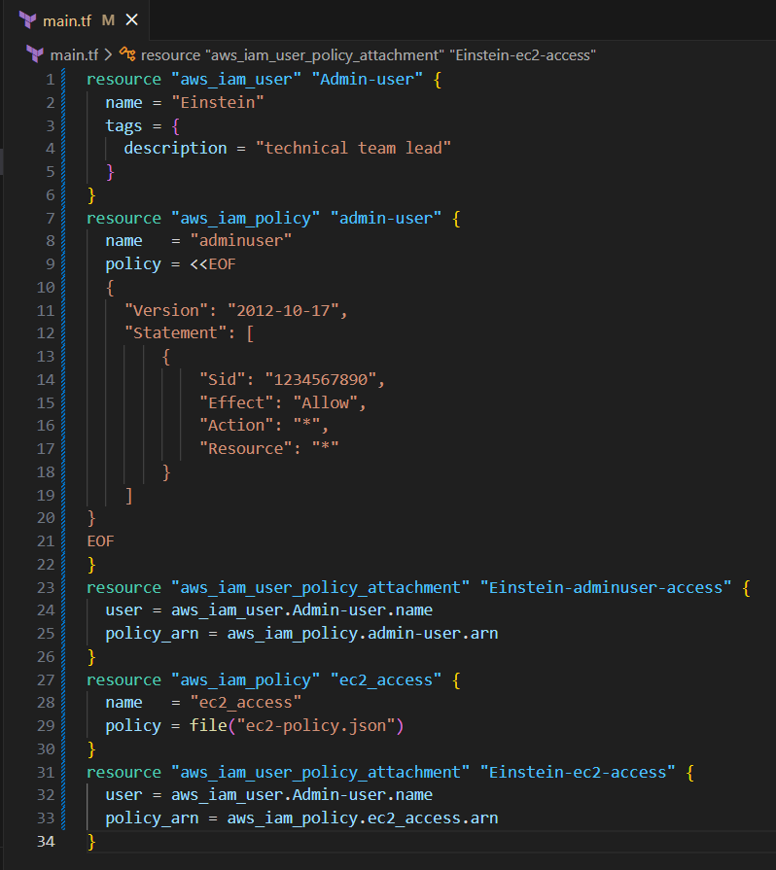

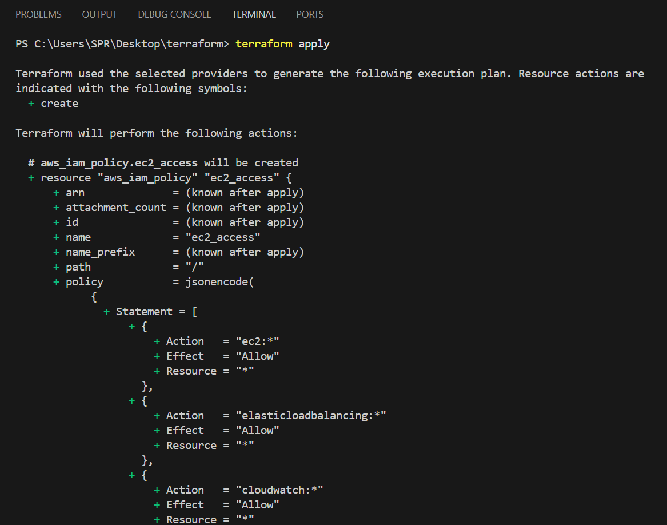
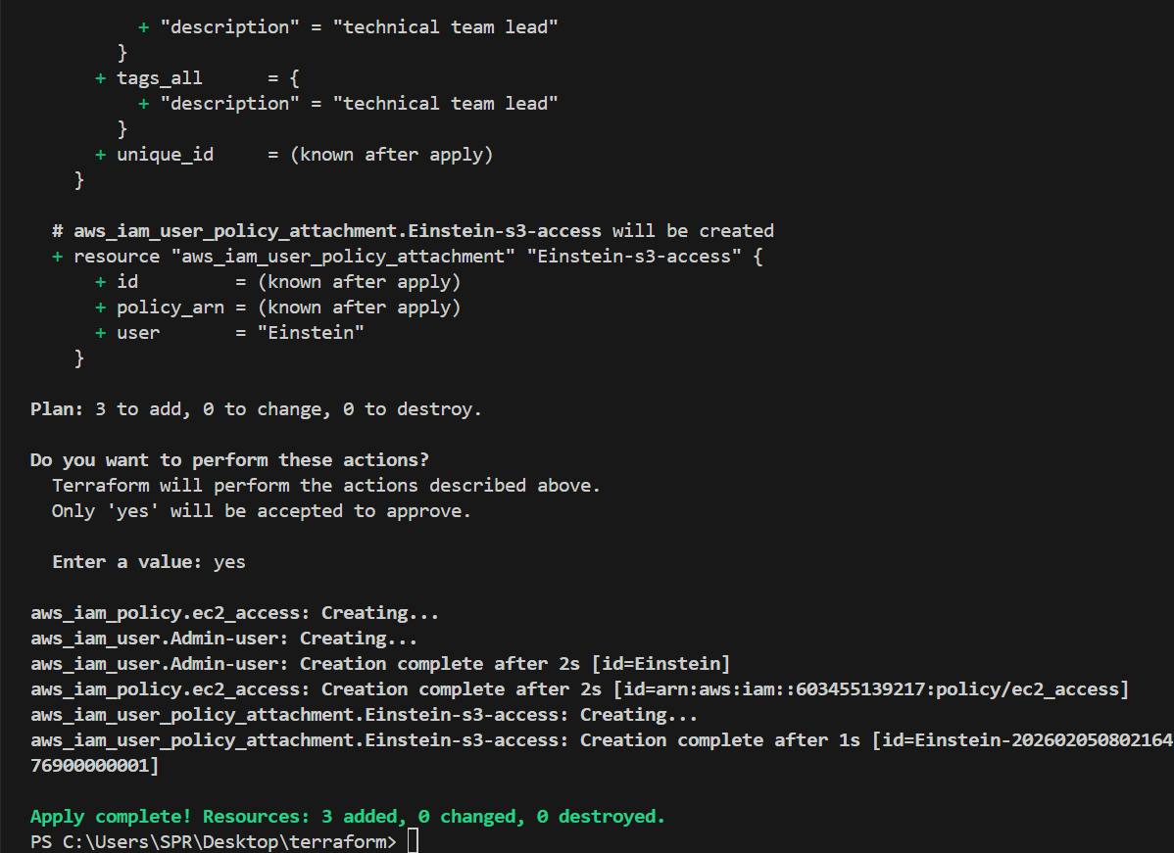

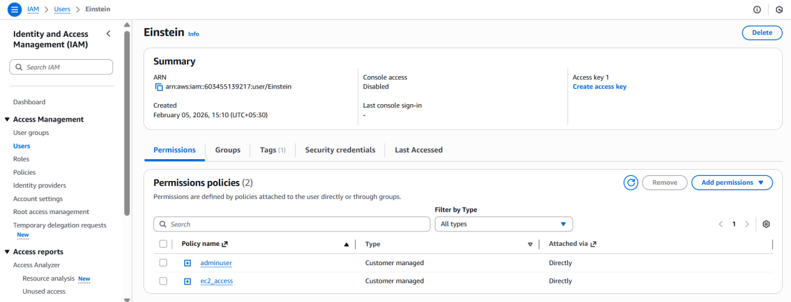

- Integrate Terraform in Jenkins using the Terraform plugin.

1. Prerequisites

Before starting, ensure the following are in place:

### Infrastructure & Software

* Jenkins installed and running
* Java (JDK 11 or 17 recommended)
* Terraform installed on Jenkins server **OR** use Terraform via Jenkins plugin
* Git installed on Jenkins server
* Access to a cloud provider (AWS / Azure / GCP)

### Jenkins Requirements

* Admin access to Jenkins
* Required Jenkins plugins:

* **Terraform Plugin**
* **Git Plugin**
* **Pipeline Plugin**
* **Credentials Binding Plugin**

### Source code management

https://github.com/wallmore/terraform.git

* Git repository with Terraform code (main.tf , ec2-policy.json)

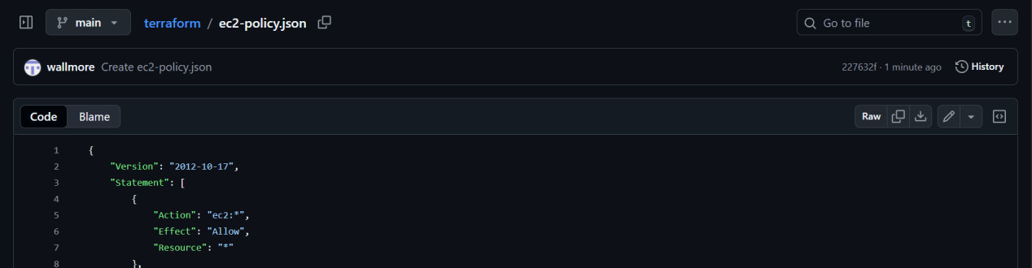

Add ec2 policy in it as we are calling the file locally in main.tf file.

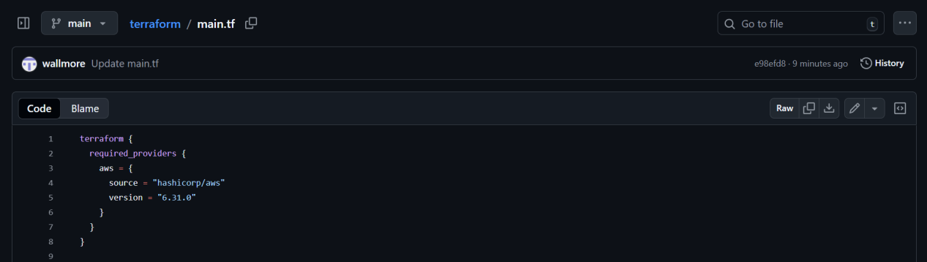

terraform {
required_providers {
aws = {
source = "hashicorp/aws"
version = "6.31.0"
}
}
}

provider "aws" {
region = "us-east-1"
}
resource "aws_iam_user" "Admin-user" {
name = "Einstein"
tags = {
description = "technical team lead"
}
}
resource "aws_iam_policy" "admin-user" {
name = "adminuser"
policy = <<EOF
{
"Version": "2012-10-17",
"Statement": [
{
"Sid": "1234567890",
"Effect": "Allow",
"Action": "*",
"Resource": "*"
}
]
}
EOF
}
resource "aws_iam_user_policy_attachment" "Einstein-adminuser-access" {
user = aws_iam_user.Admin-user.name
policy_arn = aws_iam_policy.admin-user.arn
}
resource "aws_iam_policy" "ec2_access" {
name = "ec2_access"
policy = file("ec2-policy.json")
}
resource "aws_iam_user_policy_attachment" "Einstein-ec2-access" {
user = aws_iam_user.Admin-user.name
policy_arn = aws_iam_policy.ec2_access.arn
}

2. Step-by-Step Implementation

### Step 1: Install Terraform , pipeline-stageview , git Plugin in Jenkins

1. Login to Jenkins → **Manage Jenkins** → **Manage Plugins**
2. Go to **Available**
3. Search for **Terraform Plugin , pipeline-stageview , git**

### Step 2: Configure Terraform Tool in Jenkins

1. Go to **Manage Jenkins** → **Global Tool Configuration**
2. Scroll to **Terraform**
3. Click **Add Terraform**
4. Provide:

* Name: `terraform`
* Install automatically (recommended) OR provide local Terraform path
5. Save

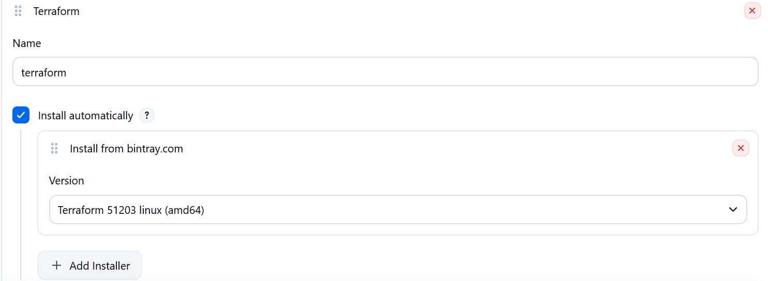

### Step 3: Add Cloud Credentials in Jenkins

1. Go to **Manage Jenkins** → **Credentials**
2. Add new credentials:

* Kind: aws_credentials / acceskeyid & secret-accesskey
* ID: `aws-creds` (example)

And also in jenkins server :

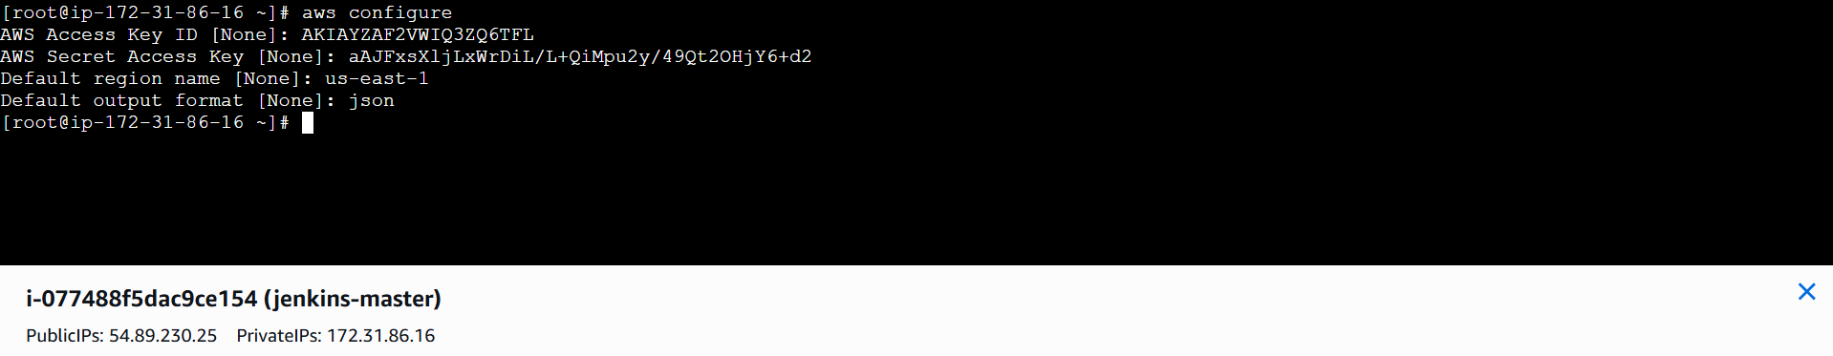

3. Save

### Step 4: Create Jenkins Pipeline Job

1. Go to Jenkins Dashboard → **New Item**
2. Select **Pipeline**
3. Name it: `aws-users-policy`

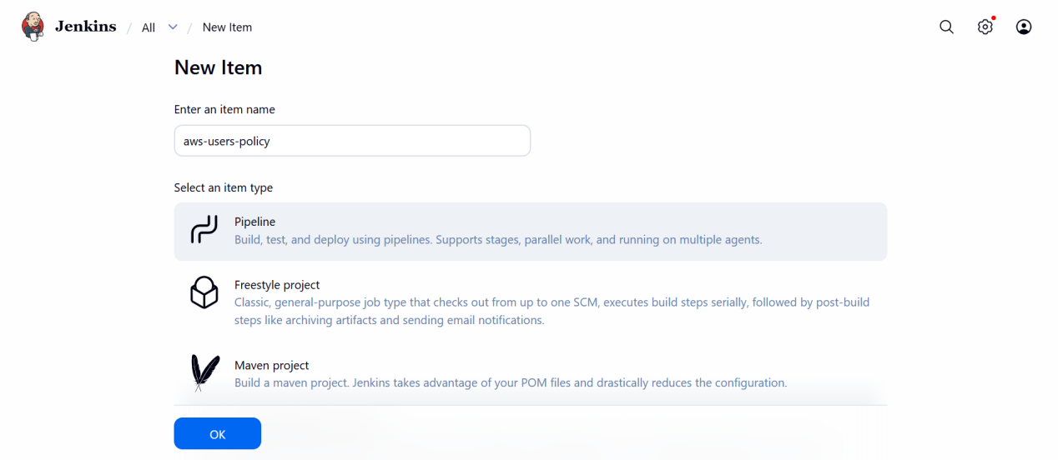

### Step 5: Jenkinsfile (Pipeline Script)

Create a `jenkinsfile` in your Git repo:

pipeline {
agent any

tools {
terraform 'terraform'
}

environment {
GIT_URL = "https://github.com/wallmore/terraform.git"
GIT_BRANCH = "main"
}

stages {

stage('Git Clone') {
steps {
git branch: "${GIT_BRANCH}",
url: "${GIT_URL}"
}
}

stage('Terraform Init') {
steps {
withCredentials([
[$class: 'AmazonWebServicesCredentialsBinding',
credentialsId: 'aws-creds']
]) {
sh 'terraform init'
}
}
}

stage('Terraform Plan') {
steps {
withCredentials([
[$class: 'AmazonWebServicesCredentialsBinding',
credentialsId: 'aws-creds']
]) {
sh 'terraform plan'
}
}
}

stage('Terraform Apply') {
steps {
withCredentials([
[$class: 'AmazonWebServicesCredentialsBinding',
credentialsId: 'aws-creds']
]) {
sh 'terraform apply -auto-approve'
}
}
}
}
}
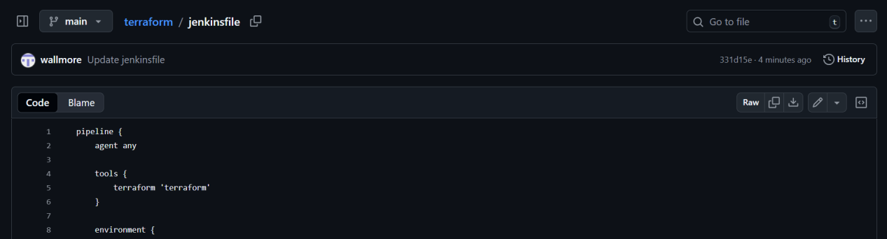

### Step 6: Configure Git Repository in Jenkins Job

* In Pipeline job:

* Definition: **Pipeline script from SCM**
* SCM: Git
* Repository URL: your Terraform repo
* Branch: main
* Script Path: jenkinsfile

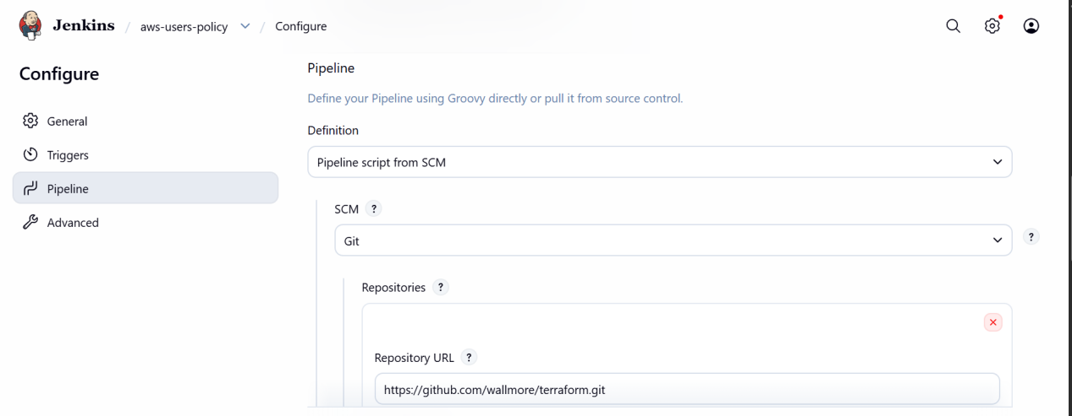
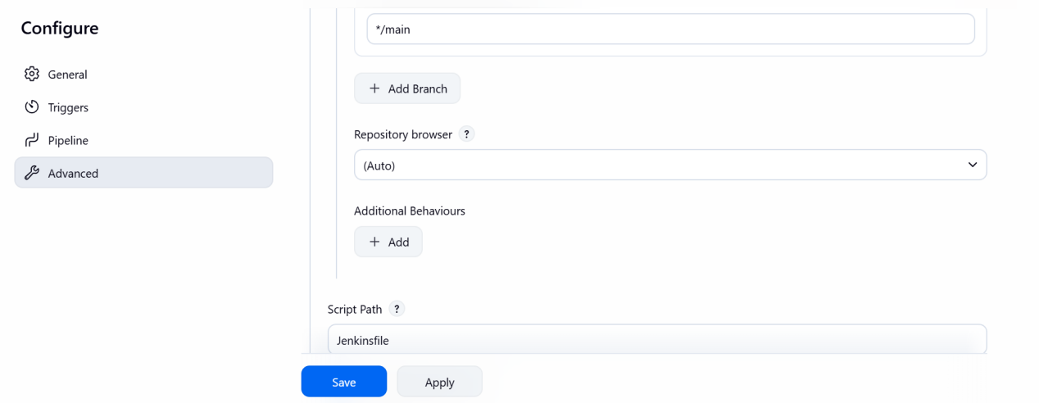

### Step 7: Build the Job

Click **Build Now** to trigger the pipeline.

3. Validation Steps

### Validation 1: Jenkins Console Output

Check Jenkins build logs for:

* `terraform init` completed successfully
* `terraform validate` passed
* `terraform plan` generated
* `terraform apply` executed without errors

### Validation 2: Terraform State

Verify:

* `terraform.tfstate` created (locally or in remote backend like S3)
* In AWS check user created with policy’s attached in

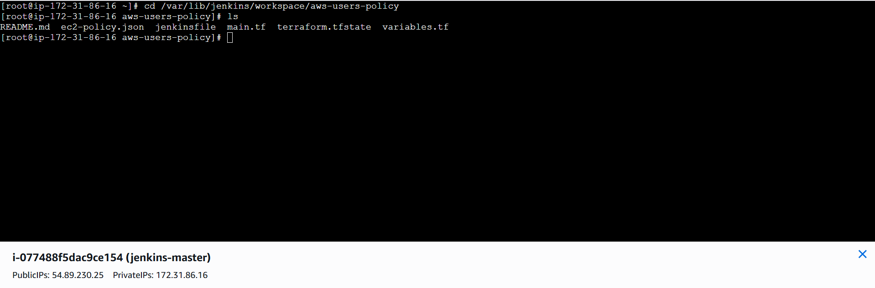

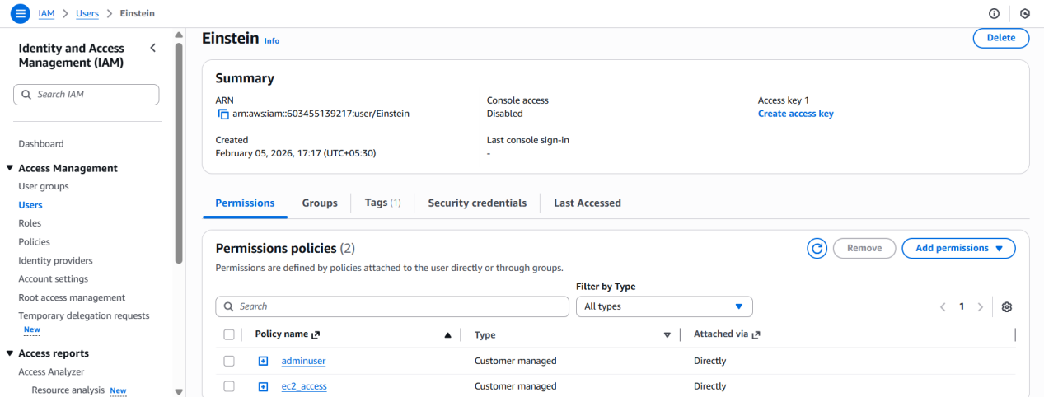

### Validation 4: Jenkins UI

* Job status should be **SUCCESS**
* All stages should be green

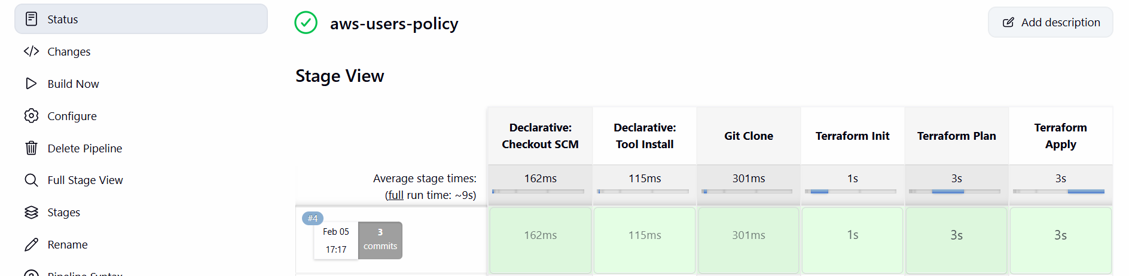

- Create a CI/CD pipeline for a Nodejs Application: https://github.com/betawins/Trading-UI.git

Prerequisites:

* Install nodejs plugin in jenkins
* add node js in tools .
Manage jenkins --> tools --> add node js -->
Name = nodejs .
Select install automatically and version 18.

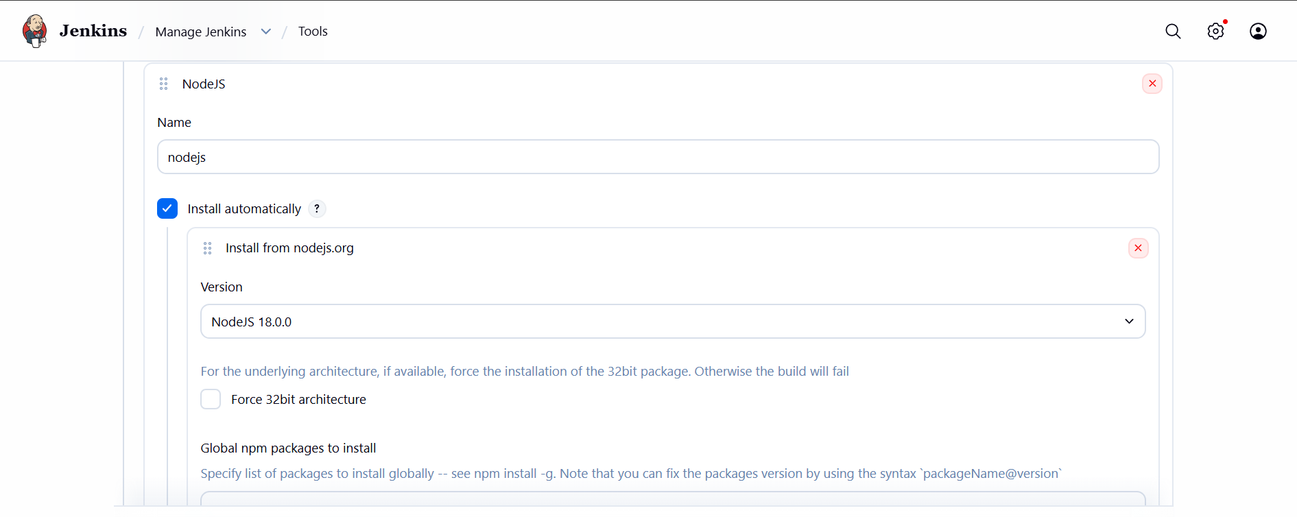

Steps :

* create a jenkins pipeline job .

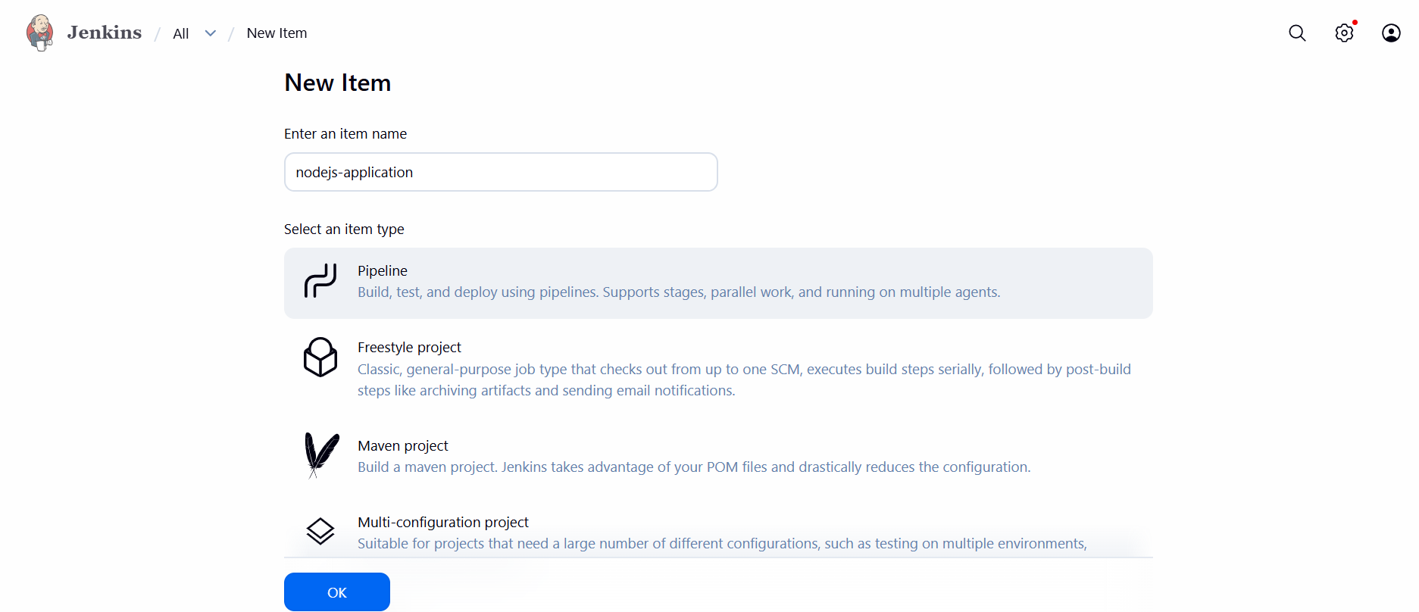

*Configure Git Repository in Jenkins Job

* In Pipeline job:

* Definition: **Pipeline script from SCM**
* SCM: Git
* Repository URL: https://github.com/wallmore/Trading-UI.git
* Branch: master
* Script Path: Jenkinsfile

BUILD THE JOB .

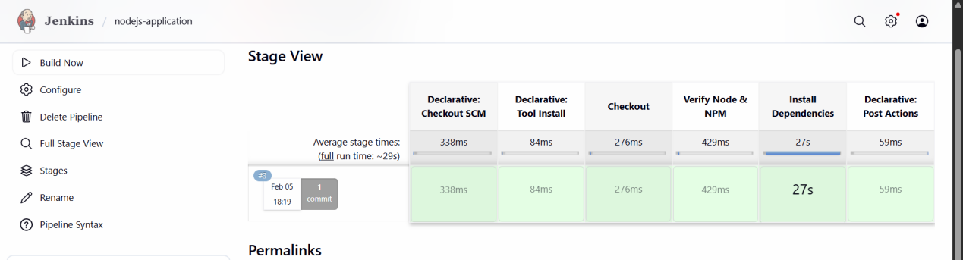

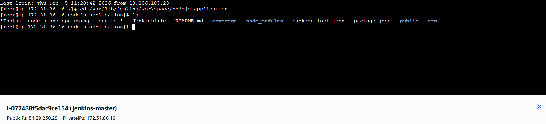

- Explain 10 Maven commands.

1. **`mvn clean`**
Deletes the `target/` directory (old compiled files).

2. **`mvn compile`**
Compiles the source code of the project.

3. **`mvn test`**
Runs unit test cases using JUnit/TestNG.

4. **`mvn package`**
Packages the compiled code into a JAR/WAR file.

5. **`mvn install`**
Installs the packaged file into the local repository (`.m2` folder).

6. **`mvn deploy`**
Uploads the package to a remote repository (like Nexus/Artifactory).

7. **`mvn clean install`**
Cleans old files and builds + installs the project in one command.

8. **`mvn validate`**
Checks whether the project structure and `pom.xml` are correct.

9. **`mvn dependency:tree`**
Displays project dependencies in a tree format.

10. **`mvn dependency:resolve`**
Downloads and resolves all project dependencies.

Maven commands help in building, testing, packaging, and managing dependencies of a Java project.

